Education Council
Network Nebraska, 2020-2022 Working Document

Overview
Objective:
• To develop a broadband, scalable telecommunications infrastructure that optimizes the quality of service to every public entity in the State of Nebraska.

Description: Network Nebraska interconnects several hundred education entities to a multipurpose core backbone extending from Omaha to Lincoln to Grand Island and Scottsbluff, and provides aggregated Internet and commercial peering services extending out to the furthest corners of the state.

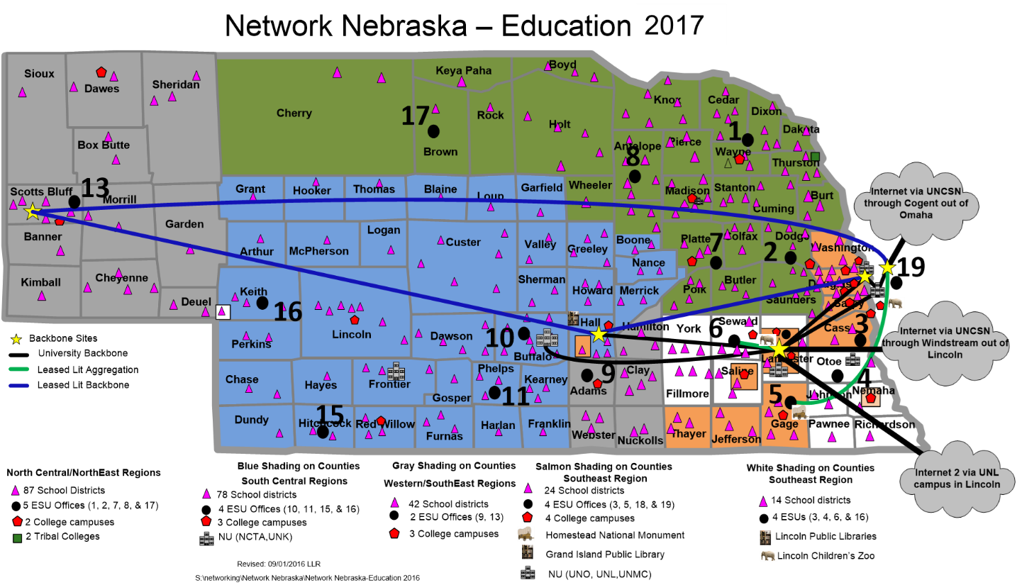

Collaborators:
• Collaborative Aggregation Partnership: Office of the CIO, University of Nebraska Computing Services Network, Nebraska Educational Telecommunications, Public Service Commission, Nebraska Department of Education, Nebraska Information Technology Commission
• Network Nebraska Advisory Group: 8 K-12 members; 8 higher education members
• Educational Service Unit (ESU) Coordinating Council, ESU-Network Operations Committee, ESU-Distance education Advisory Committee, higher education chief technology officers

Strengths/Assets:
• Every K-12 school district, educational service unit, and public college and university participate in Network Nebraska and share in its annual costs.
• Network Nebraska is a completely voluntary, self-funded project, which contributes to its resilience, sustainability and focus on customer service.
• Shared personnel support within the Office of the CIO, Administrative Services, and the University of Nebraska contribute to its ultra-low operational costs and affordability.
• Having all of the K-20 education entities on Network Nebraska provides not only a sense of pride in ownership of the network, but the daily offsets in Internet access peaks between K-12 and higher education also saves on the cost of Internet access.
Challenges/Issues:
• The absence of full-time network employees reduces the capacity for such services as marketing, communications, research & development, and customer follow-up.
• The Network Nebraska cost recovery rates, although small in comparison to other state networks, are still above what rural public libraries and private K-12 schools are accustomed to paying for Internet service provision alone.

Recent Accomplishments:
• Increased public school district participation to 100% by 7/1/2017
• Public higher education participation at 100% by 7/1/2012
• Achieved one of the lowest commodity Internet rates in the entire country, made possible through aggregation of demand and statewide bidding
• Achieved 100% retention of voluntary membership, now reaching 292 entities by 7/1/2017

Recommendations:
• Continue this initiative.
• Position Network Nebraska to provide services such as network monitoring and management, mitigation of Distributed Denial of Service (DDoS) attacks, statewide helpdesk, aggregated invoicing, and coordinated E-rate filing

Metrics
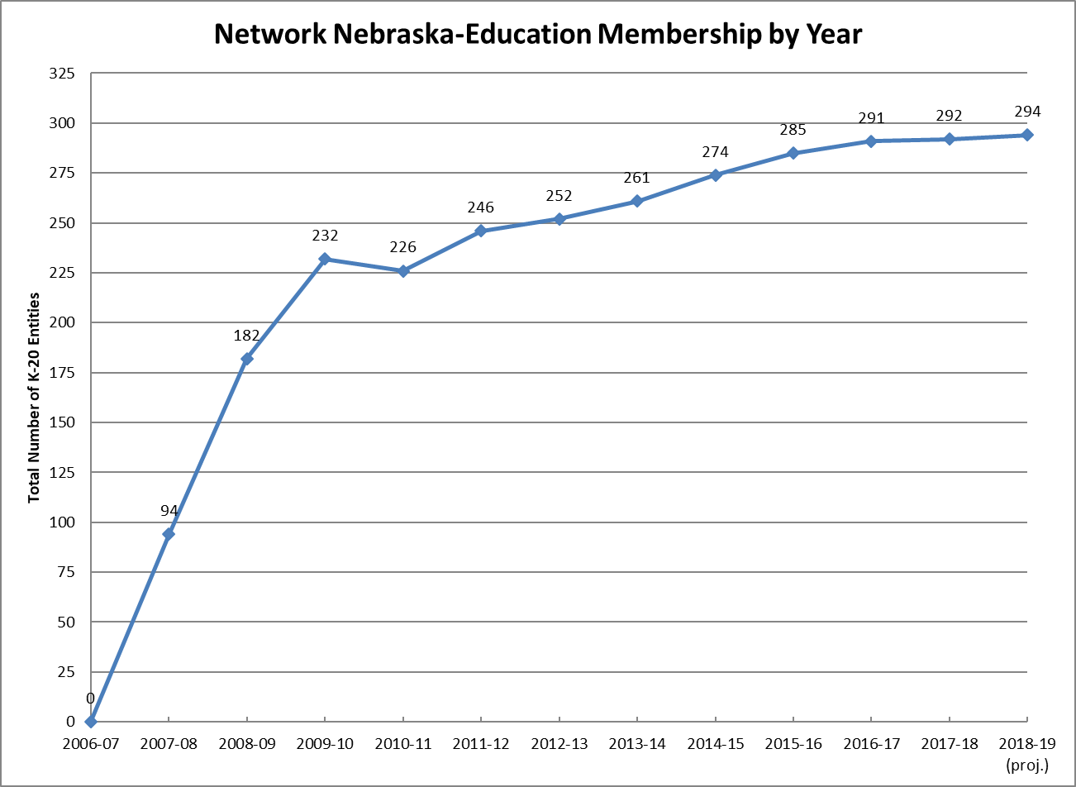

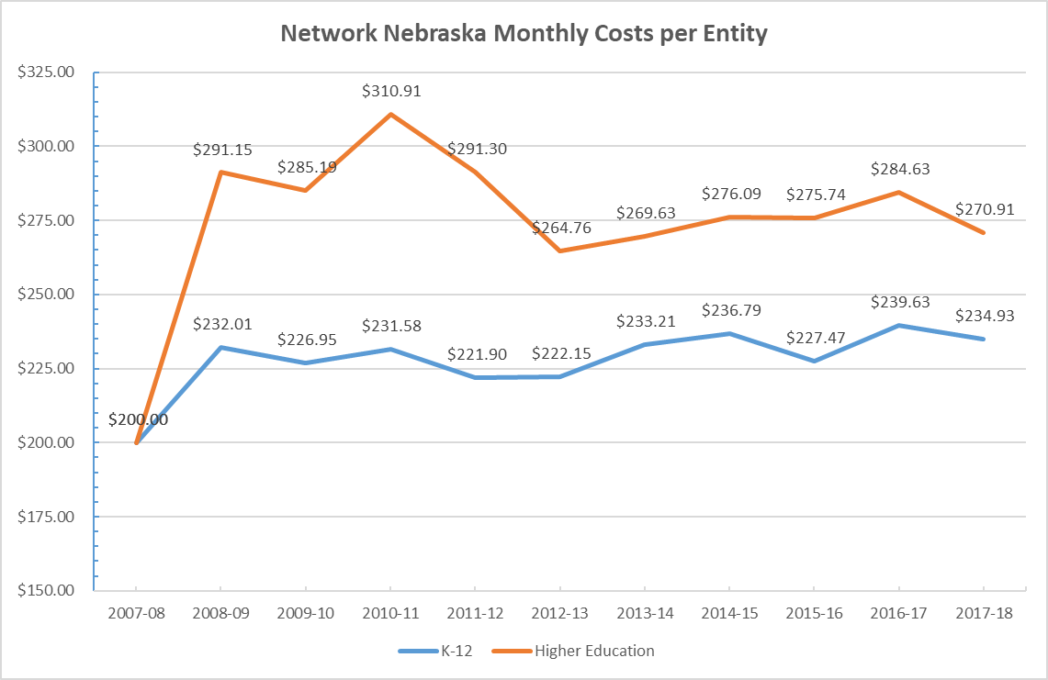
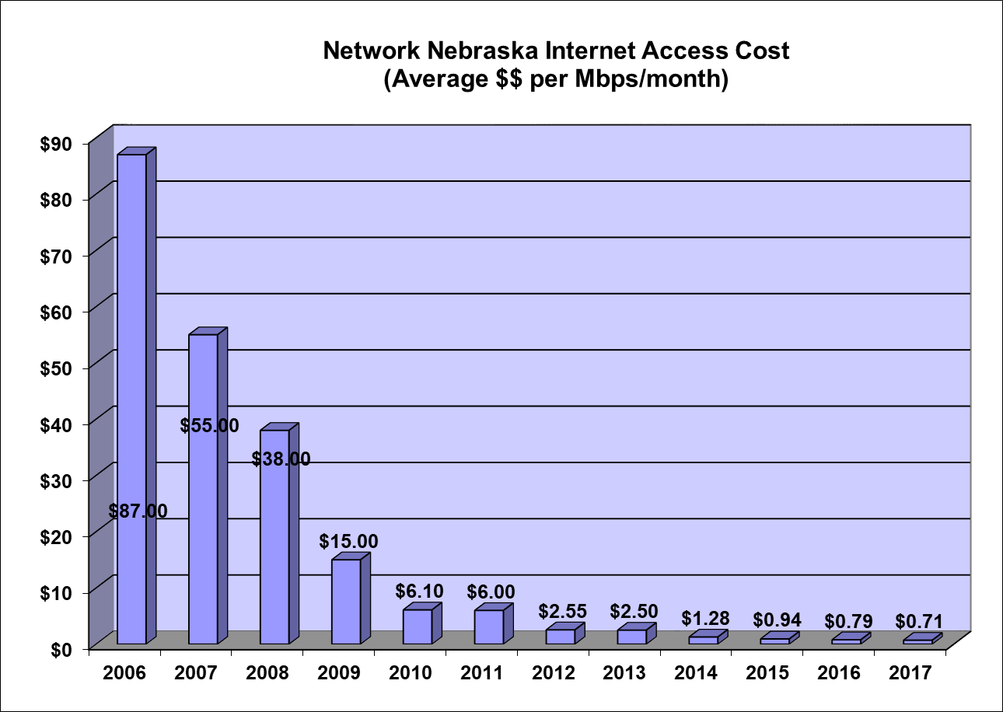

Action Items
- Action: Prepare for the future of Network Nebraska as a statewide, multipurpose, high capacity, scalable telecommunications network that shall meet the demand of state agencies, local governments, and educational entities as defined in section 79-1201.01.

Lead: Education Council

Participating Entities: Collaborative Aggregation Partnership (CAP); Network Nebraska Advisory Group (NNAG), OCIO/NITC staff

Timeframe: 2018-20

Funding: Additional funding and/or resources will be required for this action item out of the Network Nebraska Participation Fee, which is a participant-funded budget.

Targets/Deliverables:

  - The NNAG Participant Criteria subcommittee and OCIO staff will accommodate and enforce affiliate connections into Network Nebraska.
    - Measurable: A) List the types and quantities of affiliate and hosted entity connections to the network.
  - The Network Nebraska support team will use automated tools to monitor network utilization and uptime and develop a web-based graphic for real-time depiction of WAN circuits, backbone and Internet.
    - Measurable: A) Regularly present utilization statistics to NNAG and to the Network Nebraska membership in an annual report.
  - The Network Nebraska support team will implement incident management and change control frameworks appropriate to the staffing of Network Nebraska.
    - Measurables: A) Implementation of a ticketing system that allows interaction with supported users. B) Advance communication of planned outages / upgrades that affect membership. C) Documentation of past changes to core network systems.
  - NNAG and CAP will guide Office of the CIO (OCIO) decisions regarding network capacity, services, and reliability.
    - Measurables: A) NNAG co-chairs will attend monthly CAP meetings and share information. B) CAP liaisons will attend bi-monthly NNAG meetings and share information.

- Action: The Education Council and OCIO/NITC staff will serve as the communication hub for existing and potential new Network Nebraska Participants.

Lead: Education Council; OCIONITC Staff
Participating Entities: Collaborative Aggregation Partnership (CAP); Network Nebraska Advisory Group (NNAG)
Timeframe: 2018-20
Funding: Additional funding and/or resources will be required for this action item out of the Network Nebraska Participation Fee, which is a participant-funded budget.

Targets/Deliverables:

  - Develop and implement a communications strategy.
    - Measurables: A) Specific data and reports in an online newsletter or other form of communication to members outside of the annual fee memo. B) Designated representatives send timely notifications of changes in procedures affecting member relations with the Network Nebraska Support Team.
  - Conduct an annual survey of Participants to guide direction and service development.
    - Measurables: A) Survey is conducted, and data from the survey is compiled for sharing with NNAG, CAP, and the NITC Education Council.

- Action: Review the NITC IT Security Initiative and cloud computing components of the State Government IT Strategy Initiative as drafted by the NITC State Government Council.
Lead: Education Council; NNAG
Participating Entities:
Timeframe: 2018-20
Funding: No additional funding is projected for this action item.

  - Develop applicable practices and strategies for security and cloud applications in educational environments
    - Measurables: A) Formulation of a Strategy document
  - Determine how to incorporate the applicable strategies within services of Network Nebraska.
    - Measurables: A) Additional services or security practices added to NN services list or provided by member “centers of excellence.”

Other Recommended Measurables:
- Network Nebraska backbone uptime
- Network Nebraska Internet access uptime
- Network Nebraska backbone bandwidth utilization (actual)
- Network Nebraska membership growth
- Network Nebraska Internet growth (purchased and actual)
- Network Nebraska unit cost of Internet
- Number of public and non-profit, non-education entities (e.g., libraries) connected to Network Nebraska

